# Assignment-1

PythonProgramming

|  |  |
| --- | --- |
| Assignment Date | 2 NOVEMBER 2022 |
| Student Name | SUBHAASH G, SANTHOSH KUMAR M, ROHITH R, RAHUL P |
| Team ID | PNT2022TMID13631 |
| Maximum Marks | 2 Marks |

# Question-1:

Write a program which will find all such numbers which are divisible by 7 but are not a multiple of 5,between 2000 and 3200 (both included). The numbers obtained should be printed in a comma-separatedsequenceona single line.

|  |
| --- |
| **Solution:** |
| a=[]  for i in range(2000, 3201):  if (i%7==0) and (i%5!=0):  a.append(str(i))  print (','.join(a)) |
|  |

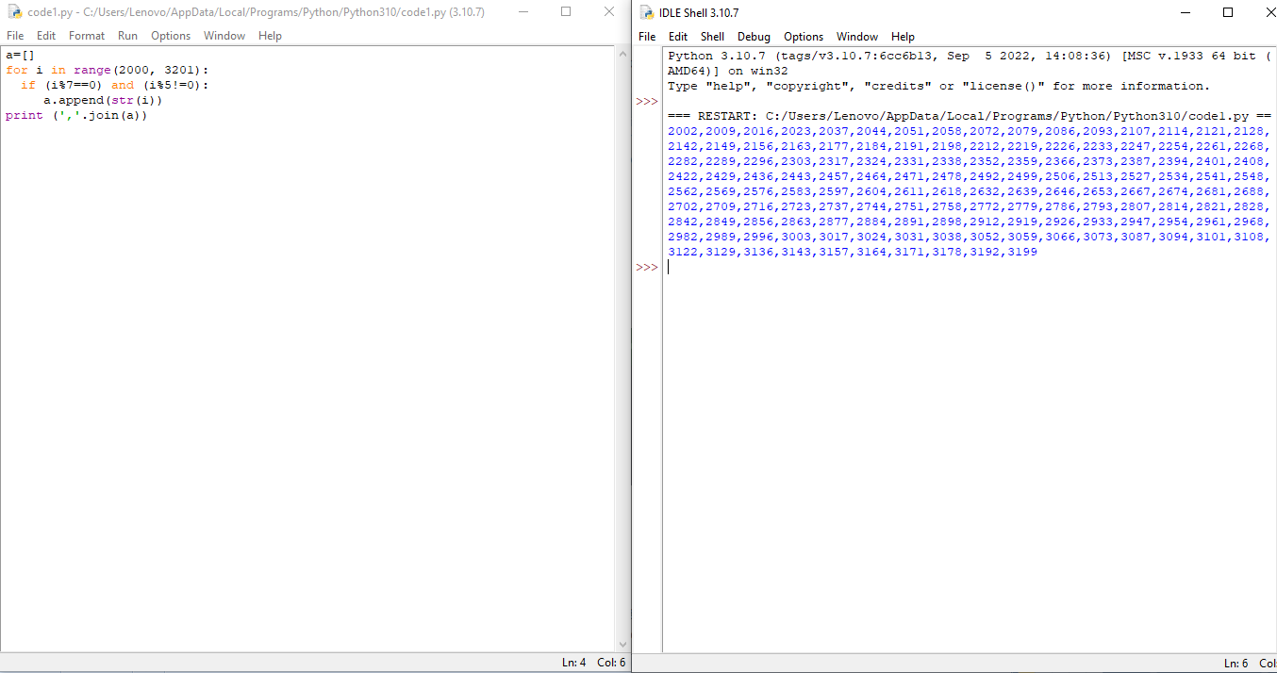

# Question-2:

Withagivenintegralnumbern,writeaprogramtogenerateadictionarythatcontains(i,i*i)suchthatis an integral number between 1 and n (both included). and then the program should print thedictionary.

Suppose the following input is supplied to the program:8

Then,theoutputshouldbe:

{1:1,2:4, 3: 9,4:16,5:25,6:36, 7: 49,8: 64}

**Solution:**

k=int(input())

s=dict()

for i in range(1,k+1):

s[i]=i*i

print(s)

